**UML Sequence Diagram**

1. **DrawProgram**

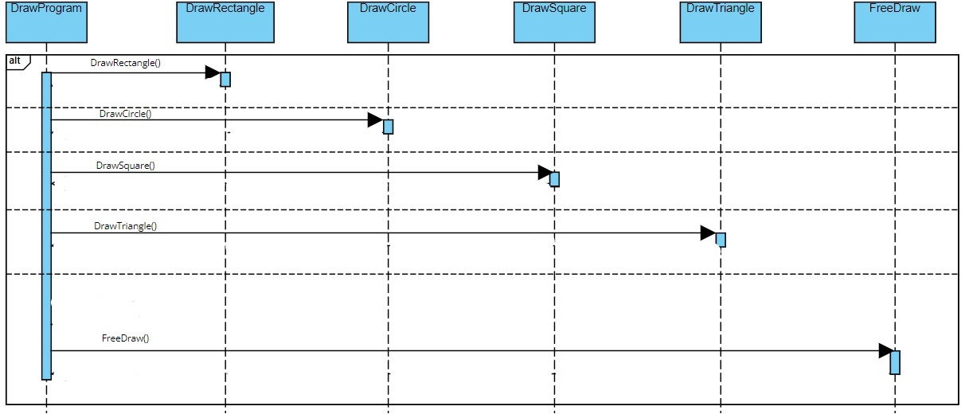

1. **DrawRectangle**

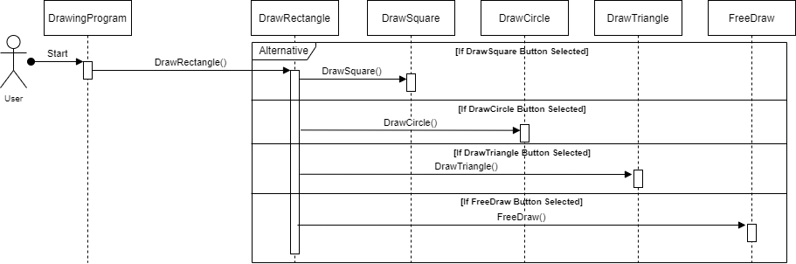

1. **DrawCircle**

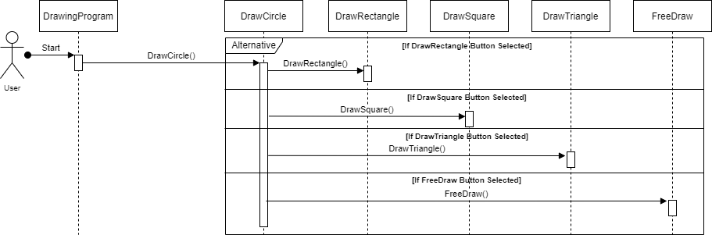

1. **DrawSquare**

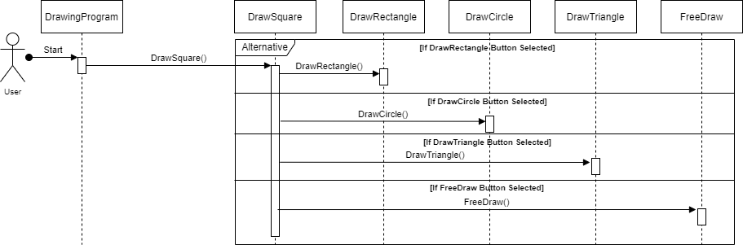

1. **DrawTriangle**

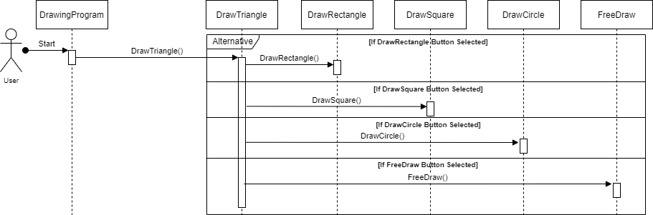

1. **FreeDraw**

